Second Project Pharmacy Website

Date:4/2/2022

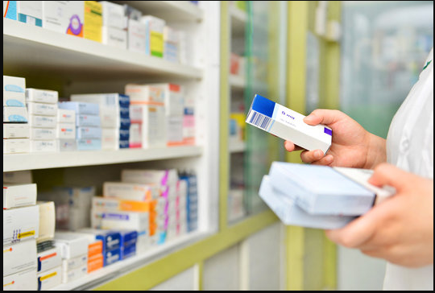

Emaa Pharmacitical Company:
Emaa Pharmacitical Company is a company which the strategy is how to discover ,clarify and concerned by the medicine according to the quality of company manufactured and the type of medicines.
Our vision :It is to provide a good quality of services to customers according to their requierments.
Our mission: It is to make a customer more satisfied according to the quality of products, prices and services.

Emaa Pharmacy website: Emaa Pharmacy website is a website with the relevant and necessary information about the medicine. Also review a many different medicine according to your all details (type, country manufacture, date of manufacture and experid date , etc..). and services that website provide to our customers. Also descripe the medicines according to the type of fields that belong to.
Technology used:
- Frontend :
1) HTML
- Css
- Bootstrap
- Java script
2) Backend:
- Programming Language
- Database (mySql)
- Server
Website Page:
- Main home page:
- Login / Sign up
- Navigation bar : Home - About us – Products (Categories ) - Our Services - Contact us.
- Home page sections:
- Header.
- Main Body.
- Footer.

1.1)Header section include
1) Logo icon and
2) Navigation bar :
1) Home.
2) About us
3) Products
- Categories
4) Our Services
5) Contact Us.

1.1.1) Logo icon: describe the company.
1.1.2) Navigation bar:
1) Home: include the rest of the page.
2) About us:Here we give some brief information about the company, the misson and vision.
3) Products: Describe the products according to thier categories for example (General Sales List, tablest , Pharmacy Medicines....etc) and also company manufactured.
- Categories: We describe the product according to thier types, for example (tablest,inheler drops ...etc).
5) Our Services:We talk about how to let customer be more satisfaction with the services that provided.
6) Contact Us:the way of how to contact with the customers.

1.2)Main Body:
1.2.1) Home page content: it contains the most unique information about the website, includes :
- Search section.(include slider images)
- Section of About us.
- Section of Why choose us.
- Contact us.

1.3) Footer section:
1) Some information about pharmacy.
2) Important links.
3) Stay in Touch.
4) Social icon.

